LIBRARY MANAGEMENT SYSTEM
Project report submitted to the
In partial fulfillment of the requirement for the award of the degree of

BACHELOR OF COMPUTER APPLICATION
Submitted by
Team members Name: Reg No:
K.HARI PRASANTH (BCA) 212305734

E.SIVAGAMI(Bsc cs & ds) 222312354

J.JAYASURYA(BCA) 212305735

S.DILLI BABU 212305929

Under the Guidance of
Mrs. P.SHIVASHAKTHI MSC., M.Phil.,
Department of Computer Science


CHENNAI COLLEGE OF ARTS & SCIENCE
(Affiliated to University of Madras)
RAJIV GANDHI SALAI (OMR), KARAPAKKAM CHENNAI – 600 097

April-2026

DECLARATION
I hereby declare that the project work entitled “LIBRARY MANAGEMENT SYSTEM” to the Department of Computer Application, “CHENNAI COLLEGE OF ARTS & SCIENCE, KARAPAKKAM.” for the partial.
Fulfillment, of the requirement for the award of the Degree of Bachelor of Computer Science with Data science. I declare that this Project or any part thereof has not been submitted for getting any degree or diploma from any University or College.

Place: Chennai Signature of the Student:

Date: E.SIVAGAMI
(REG NO:222312354)

ACKNOWLEDGEMENT
“A Little Encouragement Can Spark a great endeavor”

Behind every successful achievement lies great contribution by some great people. To then although more of gratitude is insufficient for their unlimited contribution. I take this opportunity to reveal my thank all of them who supported me in completing this project work.
I take this privilege in thanking my beloved principal
Dr P. VENKATESAN M.SC, M.Phill., P.hd for helping me to do this project

I express my sincere thanks to the Mrs. P.SHIVASHAKTHI MSC., M.Phil Head, Department of Computer Application for her valuable suggestion and guidance that the rendered throughout the project.

I particular, we are very much thankful to our Project Guide
Mrs. P.SHIVASHAKTHI MSC., M.Phil., for her involvement and lead our project to make successful. Finally we thank one and all, who were involved in the project.

I render my special thanks to my parents for encouraging me while doing this project and also for satisfying the financial requirement of this project.
Above all I thank the almighty for giving me peace of mind, physical and mental strength throughout this duration, which helped me in finishing of the project successfully.

S:NO | CONTENTS: | PAGE NO:
1 | Introduction | 1
1.1 | Synopsis | 2
2 | System Specification | 3
2.1 | Hardware Specification | 4
2.2 | Software Specification | 4
3 | Domain and Software Specification | 5
3.1 | Domain Specification | 6
3.2 | Software Specification | 7
4 | System Analysis and Study | 10
4.1 | Existing System | 11
4.2 | Proposed System | 11
4.3 | Feasibility Study | 12
5 | System Design | 13
5.1 | Data Flow Diagram | 14
5.2 | Use Case Diagram | 15
5.3 | Database Design | 15
6 | Project Description | 18
6.1 | Modules | 19
6.2 | Module Description | 20
7 | System Testing and Implementation | 21
7.1 | Unit Testing | 22
7.2 | Integration Testing | 22
7.3 | Validation Testing | 23
7.4 | System Implementation | 23
8 | Conclusion | 25
9 | Future Enhancement | 26
10 | Appendix | 27
10.1 | Screenshots | 28
11 | Bibliography | 33

INTRODUCTION

1.INTRODUCTION:
1.1.SYNOPSIS:
The Library Management System (LMS) is a PHP–MySQL based project designed to manage and maintain records of books, students, librarians, and transactions such as issue and return. The system provides role-based dashboards for Admin, Librarian, and Students. Admin can manage users, librarians, and books; Librarians can handle book issue/return and maintain records; Students can view borrowed/returned books and search the catalogue.
The LMS ensures efficient handling of library operations, reduces manual effort, and provides a user-friendly interface with Bootstrap styling for clarity.
It improves transparency by allowing students to track their borrowing history online. The centralized database eliminates redundancy and ensures accurate record keeping. Reports generated by the system help administrators monitor overdue books and usage trends.

SYSTEM SPECIFICATION

2.SYSTEM SPECIFICATION:
2.1 Hardware requirements:
- Processor: Core i3/i5
- RAM: 4 GB DDR3
- Hard Disk: 500 GB SATA
- Monitor: LED 15”
- Keyboard/Mouse: Multimedia Keyboard, Optical Mouse

2.2 Software requirements:
- OS: Windows 7/8/10
- Frontend: HTML, CSS, Bootstrap
- Client Script: JavaScript
- Server Script: PHP
- Backend: MySQL
- Web Server: Apache (WAMPP)

DOMAIN AND SOFTWARE SPECIFICATION

3.DOMAIN AND SOFTWARE SPECIFICATION:

3.1 Domain Specification:
The Library Management System (LMS) falls under the domain of Database Management Systems (DBMS). A DBMS is software that enables efficient storage, retrieval, and management of structured data. In the context of a library, this involves handling large volumes of information about books, students, librarians, and transactions such as issue and return.

Importance of DBMS in LMS:
- Efficient Storage: All book details, student records, and transaction logs are stored in relational tables, ensuring organized and structured data management.
- Quick Retrieval: Queries can be executed to instantly fetch information such as book availability, student borrowing history, or overdue books.
- Transaction Management: Issue and return operations are handled as transactions, ensuring accuracy and consistency in records.
- Data Integrity: Primary keys (like book_id and register_no) ensure uniqueness, while foreign keys maintain relationships between tables.
- Security: Role-based access (Admin, Librarian, Student) ensures that only authorized users can perform specific operations.

DBMS Concepts Applied:
- Relational Model: Data is stored in tables (books, students, librarians, issue,return) with relationships maintained through keys.
- Normalization: Reduces redundancy by separating student details, book details, and transaction records into distinct tables.
- Query Processing: SQL queries allow searching for books, generating reports, and validating user inputs.
- Transaction Control: Issue and return operations use ACID properties (Atomicity, Consistency, Isolation, Durability) to ensure reliability.
- Concurrency Control: Multiple users (students and librarians) can access the system simultaneously without conflicts.
- Backup and Recovery: Database backups ensure that records are not lost in case of system failure.

Real-World Relevance:
Libraries traditionally relied on manual registers, which were prone to errors and time-consuming. By applying DBMS principles:
- Book availability can be checked instantly.
- Students can view their borrowing history online.
- Librarians can generate reports on overdue books and usage trends.
- Admins can manage the entire system centrally.
Thus, the LMS leverages DBMS to transform traditional library operations into a modern, efficient, and reliable system.

3.2 SOFTWARE SPECIFICATION:
Section explains the various software tools and technologies used to build the Library Management System (LMS). The project is developed using PHP and MySQL as the core technologies, with HTML, CSS, Bootstrap, and JavaScript for the frontend design and interactivity.

Frontend Technologies:
HTML (Hypertext Markup Language)
- Defines the structure of web pages.
- Used to create forms for login, book issue/return, and student registration.
- Provides semantic elements like for organizing library records
- Act as the backbone of the lms interface.
- Provides table elements for organizing student records, borrowed books, and return logs in a clear, structured format.

CSS (Cascading Style Sheets):
  - Styles the HTML elements to make the interface visually appealing.
  - Used for layout, colours, fonts, and spacing.
  - Ensures consistency across all pages (login, dashboards, reports).
  - External CSS files are linked for modular design.
  - Allows hover effects, transitions, and animations to enhance interactivity and improve user experience.
Bootstrap Framework:
  - A responsive CSS framework used to design modern, mobile-friendly dashboards.
  - Provides ready-made components like navigation bars, modals, buttons, and tables.
  - Ensures the LMS looks professional and adapts to different screen sizes.
Backend Technologies:
PHP (Hypertext Preprocessor):
  - Server-side scripting language used to handle business logic.
  - Manages user authentication, book issue/return transactions, and report generation.
  - Connects the frontend with the database using SQL queries.
  - Provides role-based access (Admin, Librarian, Student).
MySQL Database:
  - Stores all records related to books, students, librarians, and transactions.
  - Tables include:
    - books (book_id, title, author, availability)
    - students (register_no, name, course, contact)
    - librarians (lib_id, name, handled_by)
    - issue_return (transaction_id, book_id, register_no, issue_date, return_date)
  - Ensures data integrity through primary and foreign keys.
  - Supports queries for searching books, generating overdue reports, and tracking student borrowing history.
Additional Tools:
JavaScript:
  - Provides client-side validation (e.g., checking empty fields in login or issue forms).
  - Enhances interactivity (dynamic search, form validation, alerts).
  - Used for responsive elements like dropdowns and modals in combination with Bootstrap.

Web Server Environment:
  - Apache (wamp server):
  - Hosts the LMS locally.
  - Provides PHP execution and MySQL database services.
  - Ensures smooth testing and deployment on localhost.

Summary:
The combination of HTML, CSS, Bootstrap, PHP, MySQL, and JavaScript makes the LMS a robust, user-friendly, and scalable system. Each technology plays a specific role — HTML structures the content, CSS and Bootstrap style it, JavaScript adds interactivity, PHP handles logic, and MySQL manages data storage and retrieval.

SYSTEM ANALYSIS AND STUDY

4.SYSTEM ANALYSIS AND STUDY
4.1 Existing System:
In most traditional libraries, records are maintained manually using registers or spreadsheets. This approach has several limitations:
- Error-Prone: Mistakes in issue/return records.
- Time-Consuming: Searching requires flipping through registers.
- Limited Tracking: Hard to monitor overdue books.
- Redundant: Duplicate and inconsistent entries.
- Restricted Access: Only librarians can view records.
Thus, the existing system is inefficient, lacks transparency, and fails to meet the needs of modern library operations.
4.2 Proposed System
The Library Management System (LMS) is designed to overcome the limitations of the manual system by automating all core operations. Key features include:
- Role-Based Dashboards: Separate interfaces for Admin, Librarian, and Student, ensuring clarity and security.
- Centralized Database: All records (books, students, transactions) are stored in MySQL, eliminating redundancy.
- Efficient Search: Students and librarians can instantly search for books by title, author, or ID.
- Transaction Management: Issue and return operations are recorded with timestamps, ensuring accuracy.
- Reports: Admin and Librarians can generate reports on book availability, overdue returns, and usage trends.
- User-Friendly Interface: Designed with Bootstrap for responsive and visually appealing layouts.
This proposed system ensures reliability, transparency, and efficiency in library operations.
4.3 Feasibility Study:
Technical Feasibility:
- The system is developed using widely available technologies: PHP, MySQL, HTML, CSS, Bootstrap, and JavaScript.
- Runs on Wamp Server, which provides Apache and MySQL services locally.
- Hardware requirements are minimal (Core i3/i5 processor, 4 GB RAM), making it feasible for deployment on standard PCs.
Operational Feasibility:
- The system is simple and intuitive, requiring minimal training for librarians and students.
- Role-based access ensures that each user interacts only with relevant features.
- Librarians can easily issue/return books, while students can check their borrowing history without assistance.
Economic Feasibility:
- The LMS is cost-effective as it runs on localhost, requiring no additional licensing or hosting charges.
- Open-source technologies (PHP, MySQL, Bootstrap) reduce development costs.
- Maintenance costs are minimal since the system is lightweight and modular.

SYSTEM DESIGN

5.SYSTEM DESIGN:
System design is the process of defining the architecture, components, modules, interfaces, and data for a system to satisfy specified requirements. For the Library Management System (LMS), the design focuses on ensuring smooth interaction between Admin, Librarian, Student, and the Database.
5.1 Data Flow Diagram (DFD):
The Data Flow Diagram illustrates how data moves through the LMS. It shows the interaction between users and the system, and how information is processed.
Level 0 (Context Diagram):
- Admin: Manages librarians, students, and books.
- Librarian: Issues and returns books, updates records.
- Student: Views borrowed/returned books, searches catlog.
- Database: Stores all records (books, students, transactions).
Level 1 (Detailed Flow):
- Admin → Database: Add/update/delete books, students, librarians.
- Librarian → Database: Issue/return transactions recorded.
- Student → Database: Search books, view borrowing history.
- Reports Module → Database: Generate overdue and availability reports.
This ensures that all operations are centralized and consistent.

5.2 Use Case Diagram:
The Use Case Diagram represents the functional requirements of the LMS, showing interactions between users and system functionalities.
Actors:
- Admin
- Librarian
- Student
Use Cases:
- Admin: Login, Manage Books, Manage Students, Manage Librarians, Generate Reports.
- Librarian: Login, Issue Book, Return Book, Update Records, Generate Reports.
- Student: Login, Search Book, View Borrowed Books, View Returned Books.
The diagram highlights role-based access, ensuring each actor interacts only with relevant features.
5.3 Database Design:
The database is the backbone of the LMS, designed using MySQL. It follows relational principles to ensure data integrity and efficient retrieval.
It supports normalization to avoid redundancy and maintain consistency across records
It enables fast query execution, ensuring smooth performance even with large volumes of data.
Key Tables:
- users
  - user_id (Primary Key)
  - username
  - password
  - role (Admin/Librarian)
- students
  - register_no (Primary Key)
  - name
  - course
  - email
  - phone
- books
  - book_id (Primary Key)
  - title
  - author
  - publisher
  - availability (Yes/No)
- librarians
  - lib_id (Primary Key)
  - name
  - email
  - handled_by
- issue_return
- transaction_id (Primary Key)
- book_id (Primary Key)
- register_no (Foreign Key)
- issue_date
- return_date
- status (Issued/Returned)
5.4 Relationships:
- students.register_no ↔ issue_return.register_no
- books.book_id ↔ issue_return.book_id
- users.user_id ↔ role-based access control
This design ensures normalization, avoids redundancy, and supports efficient queries for searching, reporting, and transaction management.
5.5 Security Design:
- Passwords stored with encryption for safe authentication.
- Role-based access prevents unauthorized operations.
- Validation checks ensure clean data entry.
- Session management protects against misuse.
- Backup and recovery mechanisms safeguard against data loss.

5.6 Advantages of the Design:
- Clear separation of roles and responsibilities.
- Centralized, error-free record management.
- Scalable structure for future modules (e.g., e-library, notifications).
- User-friendly interface with responsive design.

PROJECT DESCRIPTION

6.PROJECT DESCRIPTION
6.1 Modules:
- Admin Module:
  - Manages librarians, students, and books.
  - Controls user accounts and system settings.
  - Generates overall reports for monitoring library activities.
- Librarian Module:
  - Handles book issue and return transactions.
  - Updates book availability status.
  - Tracks which librarian processed each transaction (handled_by).
- Student Module:
  - Allows students to log in and view their borrowed and returned books.
  - Provides search functionality to check book availability.
  - Displays due dates and return history.
- Reports Module:
- Generates reports on book availability, overdue books, and transaction history.
- Provides insights into library usage trends.
- Helps in decision-making for resource allocation.

6.2 Module Description
Admin Module:
The admin has complete control over the system. They can add, edit, and delete records of books, students, and librarians. The admin also manages user accounts and assigns roles. This module ensures that the system remains secure and organized.
Librarian Module:
The Librarian is responsible for day-to-day library operations. They issue books to students, record returns, and update the database accordingly. Each transaction is tagged with the librarian’s ID (handled by) to maintain accountability. This module ensures smooth circulation of books.
Student Module:
Students can log in to their dashboard to view the list of books they have borrowed and returned. They can also search for books by title, author, or ID to check availability. This module enhances transparency and provides students with direct access to their library records.
Reports Module:
This module generates detailed reports for Admin and Librarians. Reports include:
- Book Availability Report: Shows which books are currently available or issued.
- Overdue Report: Lists books that have not been returned within the due date.
- Transaction Report: Provides a summary of all issue and return activities.
These reports help in monitoring library performance and planning future enhancements.

SYSTEM TESTING AND IMPLEMENTATION

7.SYSTEM TESTING AND IMPLEMENTATION:
7.1 Unit Testing:
Unit testing focuses on testing individual modules or components of the system in isolation.
- Login Module: Verified that only valid credentials allow access, and role-based dashboards are correctly displayed.
- Issue Module: Checked that book issue transactions update the database correctly, reducing availability count.
- Return Module: Ensured that returning a book updates the status and availability in the database.
- Search Module: Tested search functionality for books by title, author, or ID.
Each module was tested independently to confirm that it performs its intended function without errors.
7.2 Integration Testing:
Integration testing ensures that different modules work together seamlessly.
- Verified that the Admin Module correctly interacts with the Librarian Module when assigning tasks.
- Checked that book issue/return transactions in the Librarian Module reflect accurately in the Reports Module.
- Confirmed that student borrowing history in the Student Module is updated after transactions in the Librarian Module.
This testing validated smooth data flow and communication between modules.
7.3 Validation Testing:
Validation testing ensures that the system meets user requirements and handles inputs correctly.
- Register Number Validation: Confirmed that only valid student IDs are accepted during book issue.
- Book ID Validation: Ensured that only existing book IDs can be issued or returned.
- Form Validation: Checked that mandatory fields (name, email, course, book ID) cannot be left empty.
- Error Handling: Verified that invalid inputs trigger appropriate error messages.
This testing guarantees that the system prevents incorrect data entry and maintains integrity.
7.4 System Implementation:
The LMS was implemented and deployed on localhost using Wamp Server.
- Apache Server: Hosts the PHP application and executes server-side scripts.
- MySQL Database: Stores all records of books, students, librarians, and transactions.
- Environment: The system runs on Windows OS with minimal hardware requirements.
- Deployment: The project was hosted locally, allowing testing and demonstration without external hosting costs.
This implementation ensures that the system is fully functional, accessible to users, and ready for future deployment on a live server if required.

CONCLUSION

8.CONCLUSION
The Library Management System (LMS) has been successfully developed and tested to meet the requirements of modern library operations. By automating the processes of book issue, return, and record management, the system eliminates the inefficiencies of manual record keeping.

The project demonstrates how PHP, MySQL, HTML, CSS, Bootstrap, and JavaScript can be integrated to build a robust, user-friendly application. The role-based dashboards ensure that Admins, Librarians, and Students interact only with the features relevant to them, thereby improving usability and security.

Through centralized data storage, the LMS provides accurate and consistent information, making it easier to track overdue books, generate reports, and maintain accountability. The system reduces manual workload, minimizes errors, and enhances transparency in library operations.

Overall, the LMS not only streamlines day-to-day activities but also lays a strong foundation for future enhancements such as online access, notifications, and advanced analytics. It stands as a reliable and scalable solution for managing library resources efficiently.

FUTURE ENHANCEMENT

9.FUTURE ENHANCEMENT
The Library Management System (LMS), though effective in its current form, can be further improved with several enhancements. One major improvement would be providing online access so that students can search and reserve books outside the campus. The system could also integrate SMS and Email notifications to remind students of due dates and overdue books, reducing delays in returns. Another enhancement would be the inclusion of advanced analytics to track book usage trends and borrowing patterns, helping administrators make better decisions. The LMS can be extended to support digital libraries and e-books, offering students access to electronic resources alongside physical books. Introducing barcode or RFID scanning would speed up issue and return processes, minimizing manual errors.

A cloud-based deployment could allow multiple branches or institutions to share resources seamlessly. These enhancements would transform the LMS into a comprehensive solution that supports both physical and digital learning.

APPENDIX

10.APPENDIX

10.1 Screen shots:
Login page:
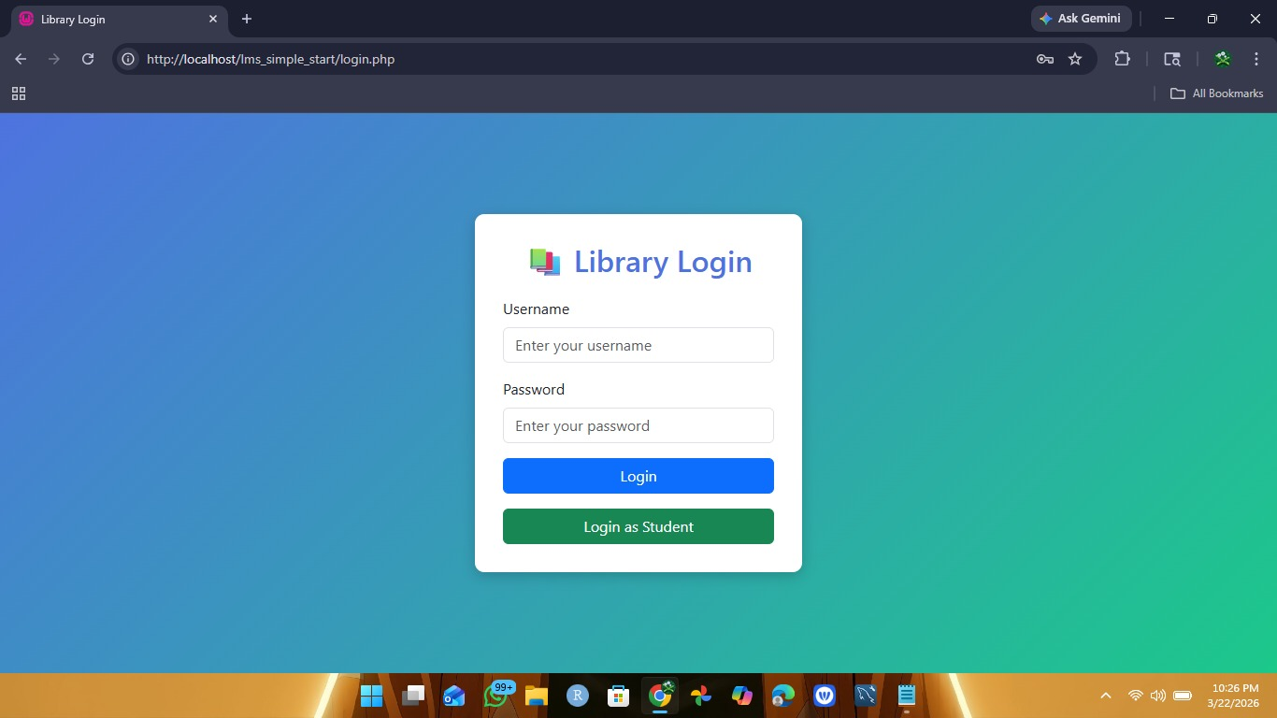

Admin dashboard:
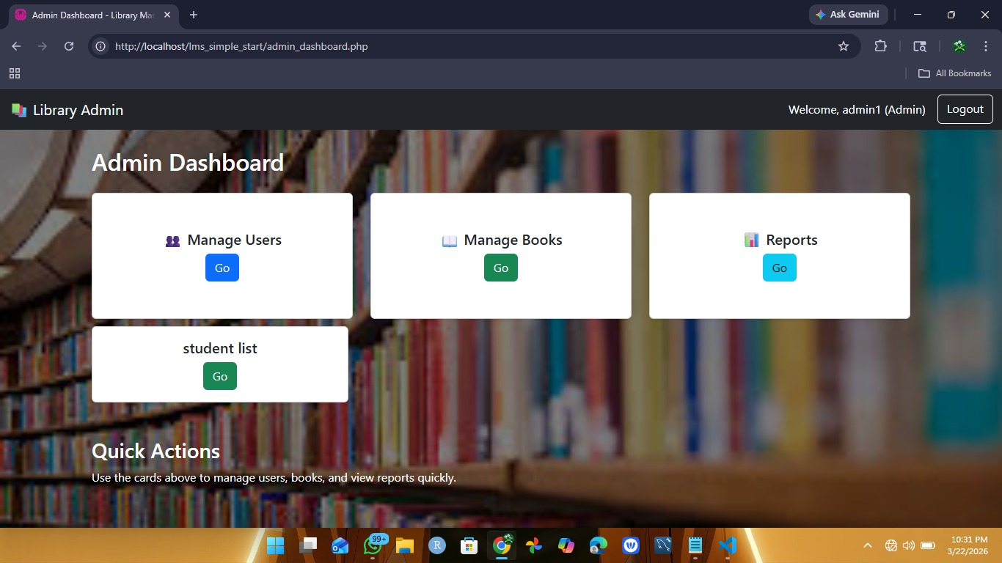

Librarian dashboard:
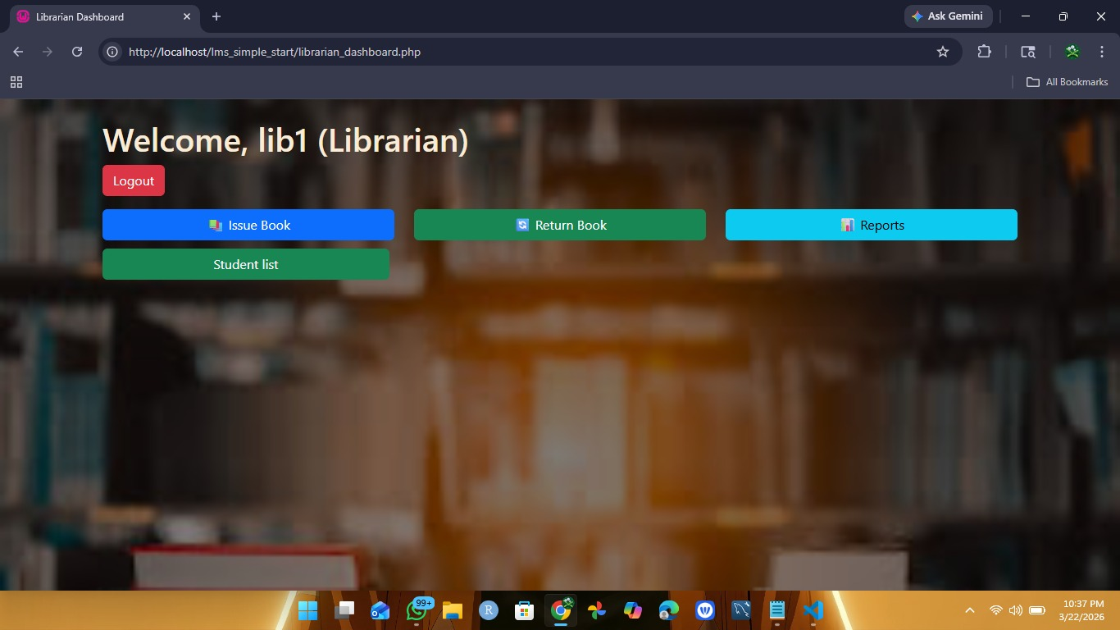

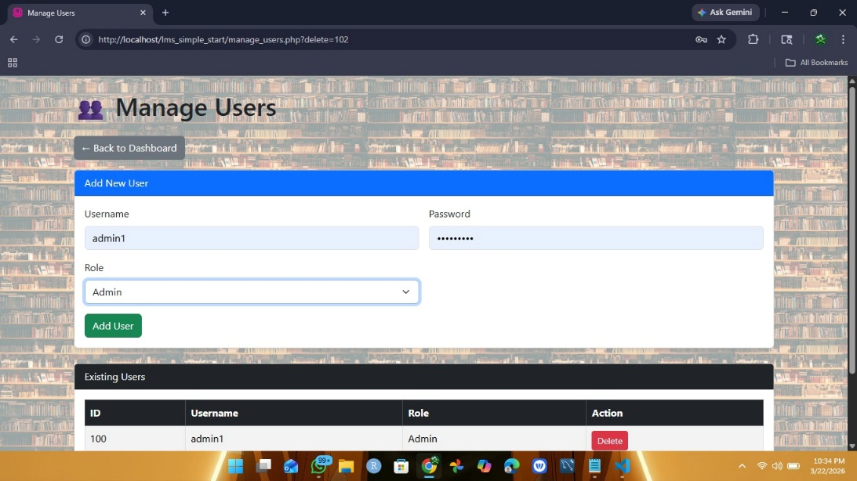
Manage Users:

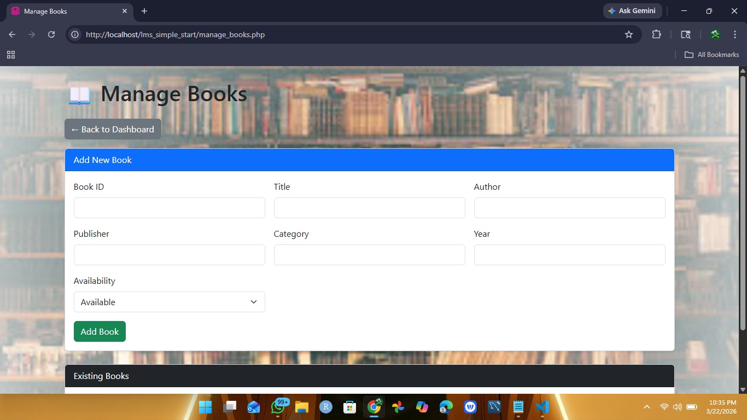
Manage Books:

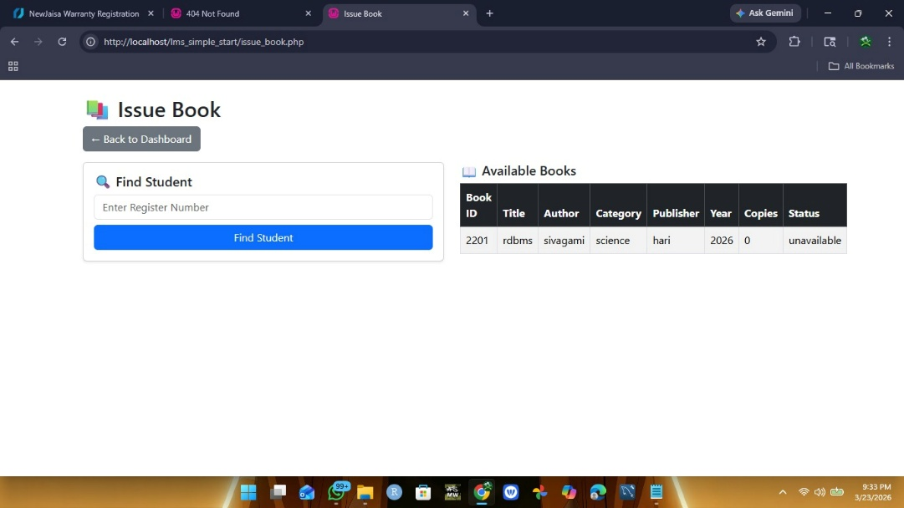
Issue Book:

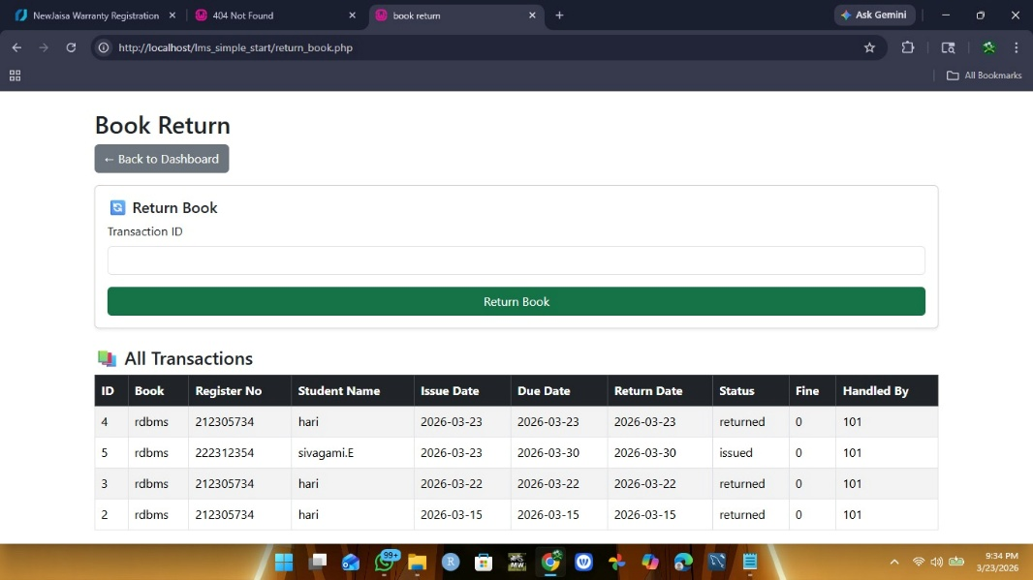
Return Books:

Reports:
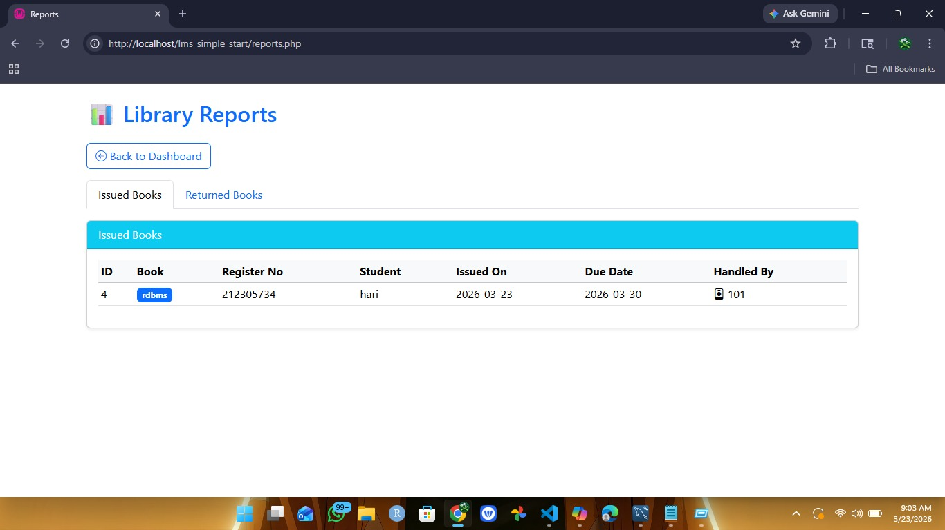

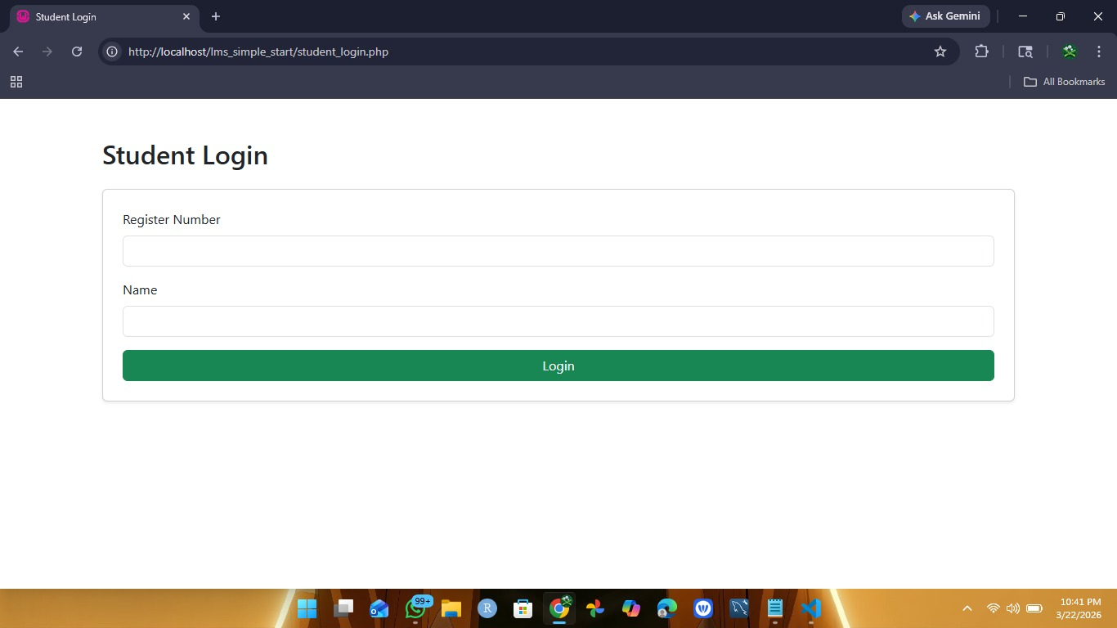
Student login:

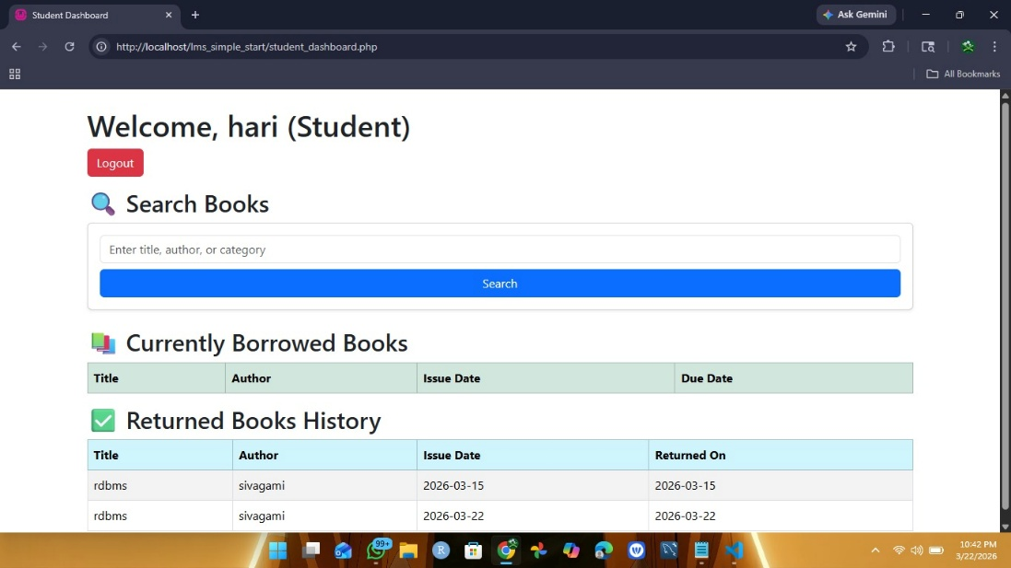
Student dashboard:

BIBLIOGRAPHY

11.BIBLIOGRAPHY:
Reference:
- PHP & MySQL Documentation
Reference for server-side scripting and database connectivity.
- W3Schools (HTML, CSS, JavaScript)
Tutorials for frontend design, styling, and validation.
- Bootstrap Framework Documentation
Guide for responsive layouts and UI components.
- JavaScript References (MDN Web Docs)
Used for client-side interactivity and form validation.
- XAMPP Server Documentation
Environment setup for Apache and MySQL on localhost.
- Open Source Community Forums
Troubleshooting and optimization tips during development.

